_________________

**BYLAW NO. 2603.21**

_________________

REGIONAL DISTRICT OF OKANAGAN-SIMILKAMEEN

BYLAW NO. 2603.21, 2021

A Bylaw to amend the Electoral Area “D” Official Community Plan Bylaw No. 2603, 2013

The REGIONAL BOARD of the Regional District of Okanagan-Similkameen in open meeting assembled, ENACTS as follows:

1. This Bylaw may be cited for all purposes as the “Electoral Area “D” Official Community Plan Amendment Bylaw No. 2603.21, 2021.”
2. The Official Community Plan Bylaw Map, being Schedule ‘B’ of the Electoral Area “D” Official Community Plan Bylaw No. 2603, 2013, is amended by changing the land use designation on:
   1. an approximately 15.7 ha portion of the land described as Lot 1, Plan KAP35151, Sublot 38, District Lot 2710, SDYD, and shown shaded purple on Schedule ‘B’, which forms part of this Bylaw, from part Resource Area (RA) to Large Holdings (LH).
   2. an approximately 1.04 ha portion of the land described as Lot 1, Plan KAP35151, Sublot 38, District Lot 2710, SDYD, and shown shaded green on Schedule ‘B’, which forms part of this Bylaw, Tourist Commercial (CT) to Large Holdings (LH).
   3. an approximately 29.2 ha portion of the land described as Lot 1, Plan KAP35151, Sublot 38, District Lot 2710, SDYD, and shown shaded yellow on Schedule ‘B’, which forms part of this Bylaw, from Resource Area (RA) to Conservation Area (CA).

READ A FIRST AND SECOND TIME this 21st day of October, 2021.

PUBLIC HEARING held on this 18th day of November, 2021.

READ A THIRD TIME this _____ day of ___________, 2021.

ADOPTED this this _____ day of ___________, 2021.

_______________________ ______________________

Board Chair Corporate Officer

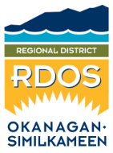Regional District of Okanagan-Similkameen

101 Martin St, Penticton, BC, V2A-5J9

Tel: 250-492-0237 Email: [info@rdos.bc.ca](mailto:info@rdos.bc.ca)

Amendment Bylaw No. 2603.21, 2021 File No. D2021.016-ZONE

Schedule ‘A’

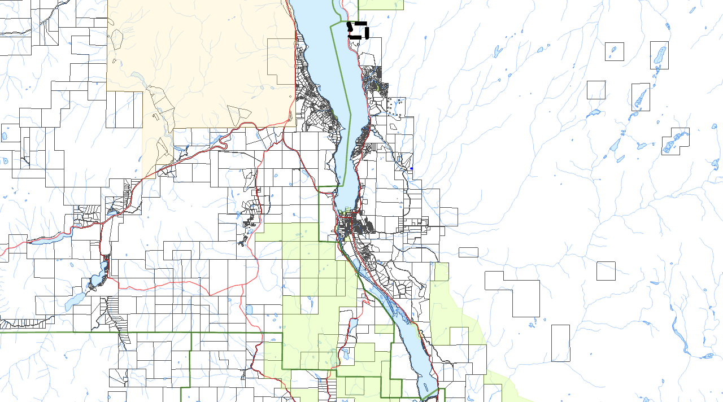



KALEDEN

Subject Parcel

OK FALLS

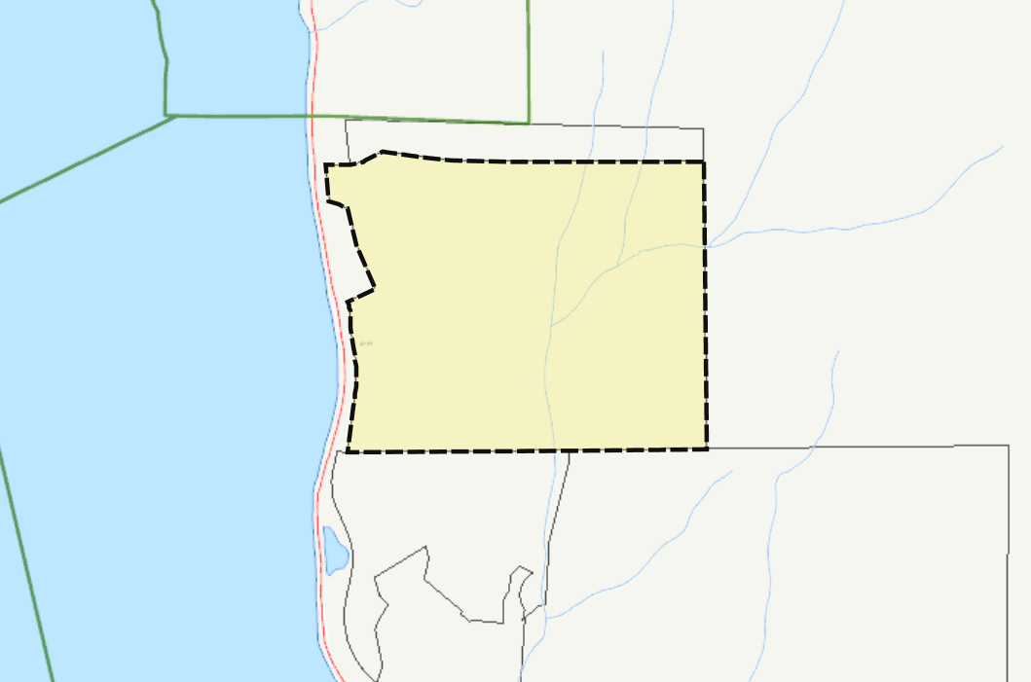

SKAHA LAKE

EASTSIDE ROAD

Regional District of Okanagan-Similkameen

101 Martin St, Penticton, BC, V2A-5J9

Tel: 250-492-0237 Email: [info@rdos.bc.ca](mailto:info@rdos.bc.ca)

Amendment Bylaw No. 2603.21, 2021 File No. D2021.016-ZONE

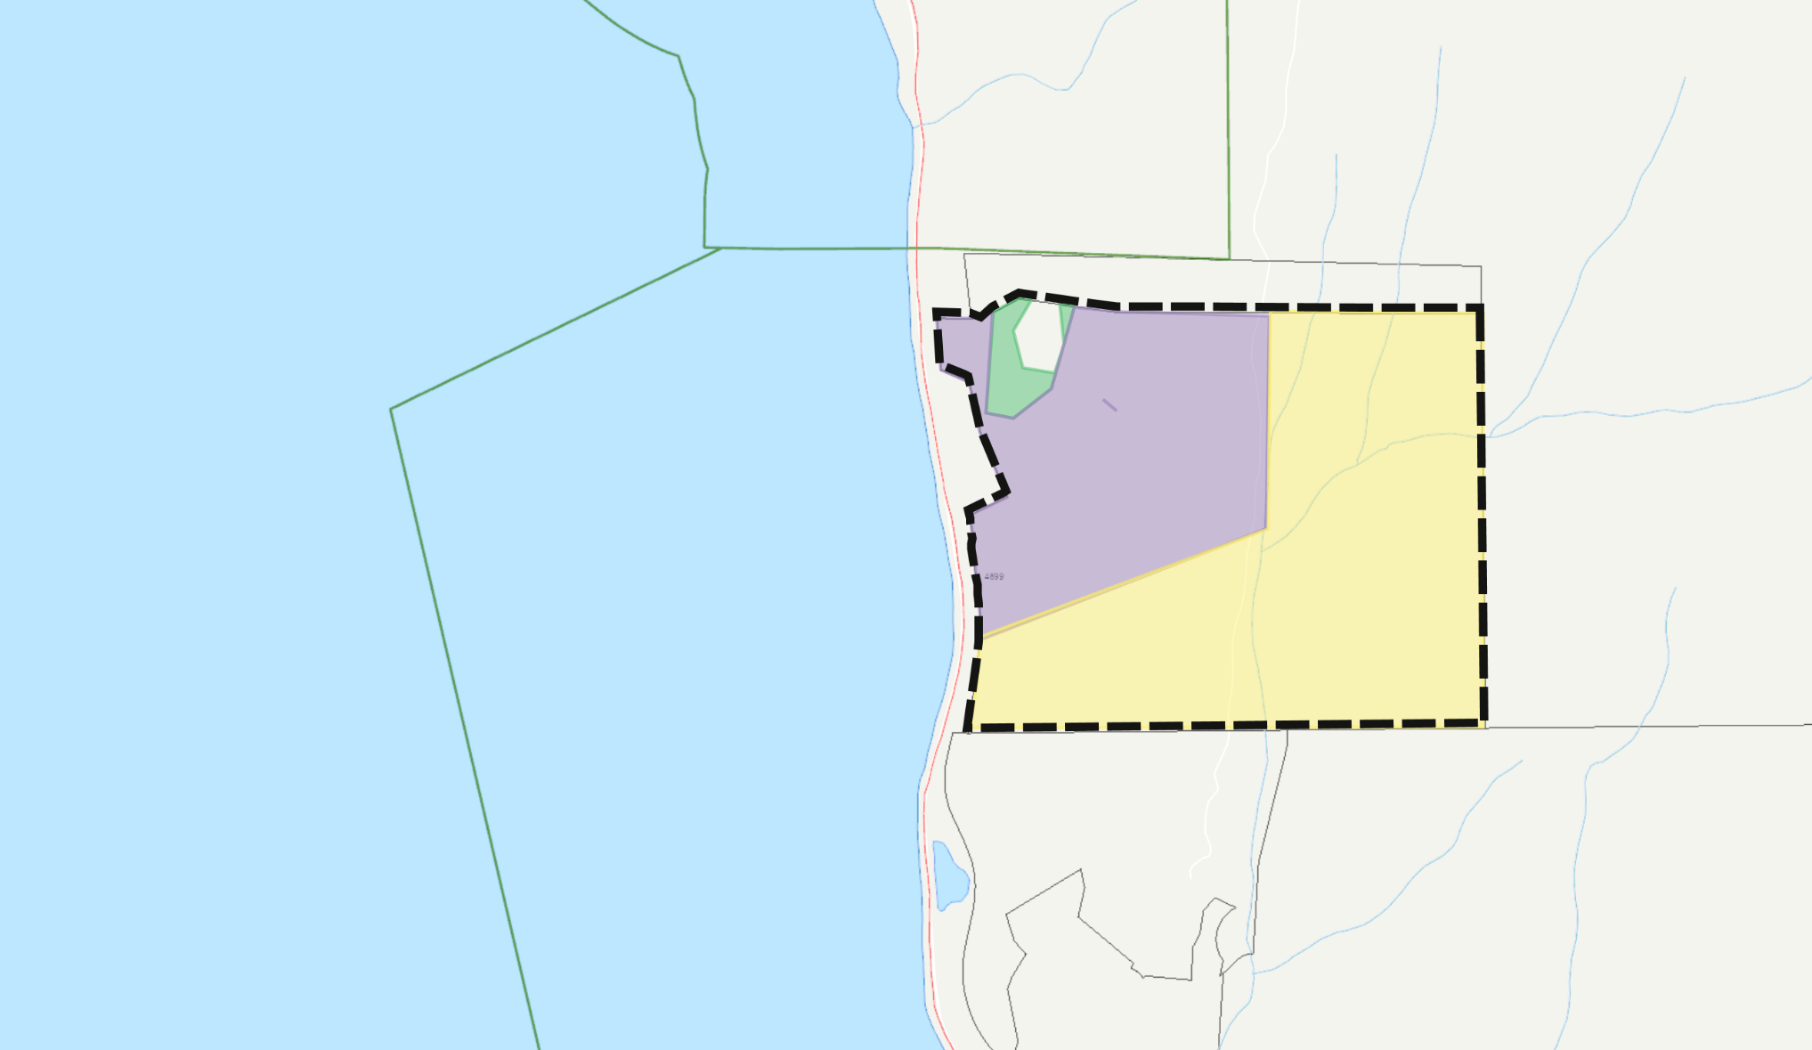Schedule ‘B’

Amend OCP Bylaw No. 2603, 2013

from: Tourist Commercial (CT)

to: Large Holdings (LH)

(GREEN SHADED AREA)

Amend OCP Bylaw No. 2603, 2013

from: Resource Area (RA)

to: Large Holdings (LH)

(PURPLE SHADED AREA)

Amend OCP Bylaw No. 2603, 2013

from: Resource Area (RA)

to: Conservation Area (CA)

(YELLOW SHADED AREA)