**_________________**

# BYLAW NO. 2800.52

**_________________**

**REGIONAL DISTRICT OF OKANAGAN-SIMILKAMEEN**

**BYLAW NO. 2800.52, 2025**

**A Bylaw to amend the Okanagan Valley Zoning Bylaw No. 2800, 2022**

The REGIONAL BOARD of the Regional District of Okanagan-Similkameen in open meeting assembled, ENACTS as follows:

1. This Bylaw may be cited for all purposes as the “Okanagan Valley Zoning Amendment Bylaw No. 2800.52, 2025.”
2. The “Okanagan Valley Zoning Bylaw No. 2800, 2022,” is amended by:
3. adding a new sub-section (ii) under Section 22.1.7(d) (Administrative and Institutional Site Specific (AIs) Regulations – Electoral Area “E”) to read as follows:
   1. in the case of an approximately 650 m2 area of land, and shown shaded yellow on Figure 22.1.7(d)(ii):
      1. the following principal use shall be permitted on the land in addition to the permitted uses listed in Section 22.1.1:

a “civic facility” use shall include fire rescue training facility, which may include training structures, equipment and vehicle storage.

Administrative and Institutional Site Specific (AIs)

(YELLOW SHADED AREA)

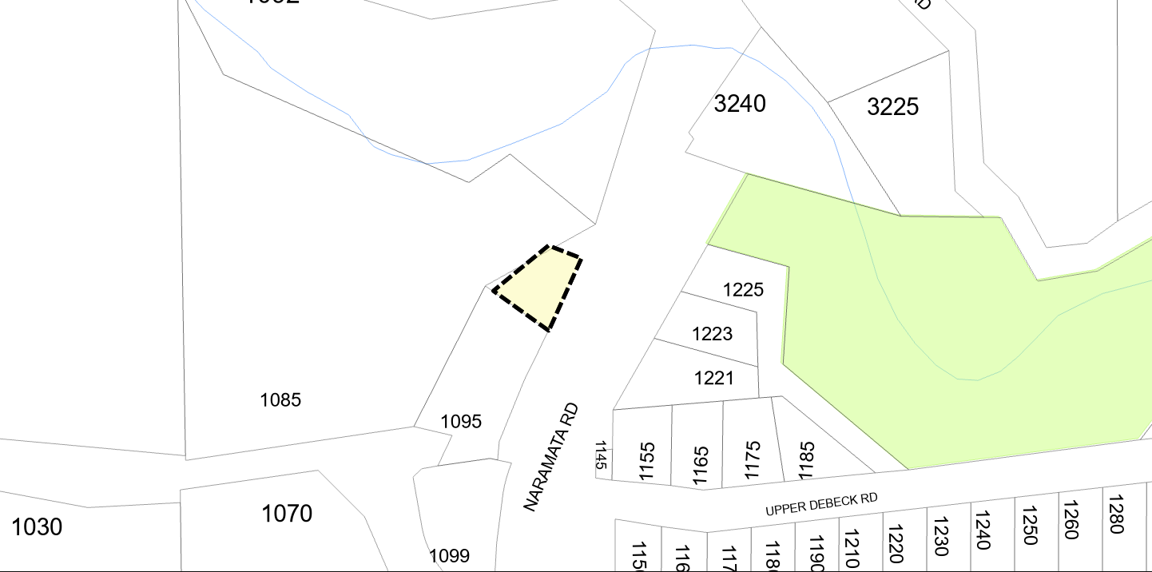

**Figure 22.1.7(d)(ii)**

1. The Official Zoning Map, being Schedule ‘2’ of the “Okanagan Valley Zoning Bylaw No. 2800, 2022”, is amended by changing the land use designation on an approximately 650 m2 area of land shown shaded yellow on Schedule ‘A’, which forms part of this Bylaw, from Agriculture One (AG1) to Administrative and Institutional Site Specific (AIs).

READ A FIRST AND SECOND TIME this _____ day of ___________, 2025.

PUBLIC HEARING held on this _____ day of ___________, 2025.

READ A THIRD TIME AND ADOPTED this _____ day of ___________, 2025.

_______________________ _________________________

Board Chair Corporate Officer

****Regional District of Okanagan-Similkameen

101 Martin St, Penticton, BC, V2A-5J9

Tel: 250-492-0237 Email: [info@rdos.bc.ca](mailto:info@rdos.bc.ca)

Amendment Bylaw No. 2800.52, 2025 File No. E2025.002-ZONE

Schedule ‘A’

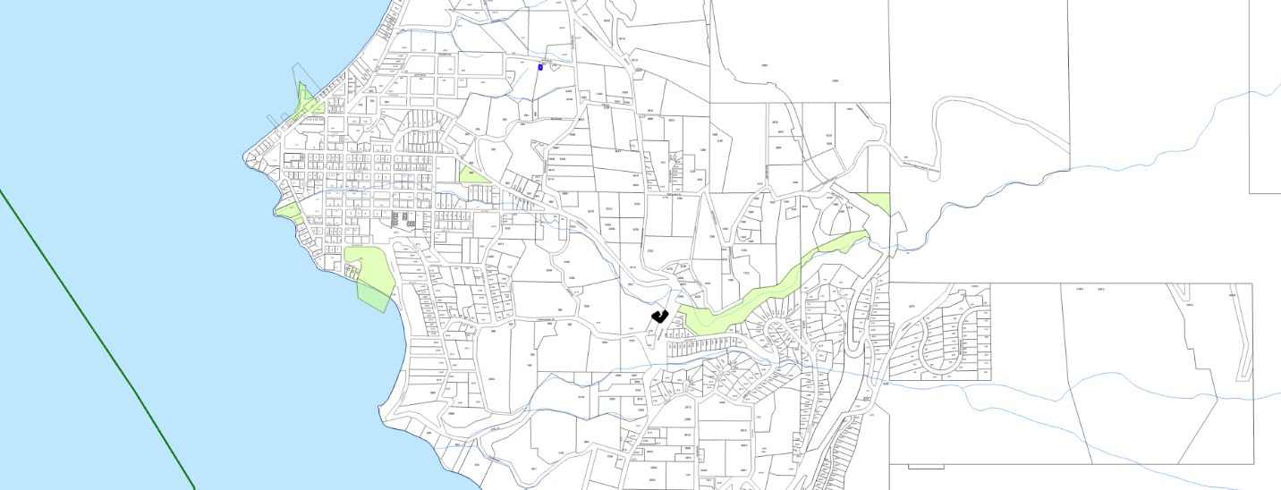



**NARAMATA**

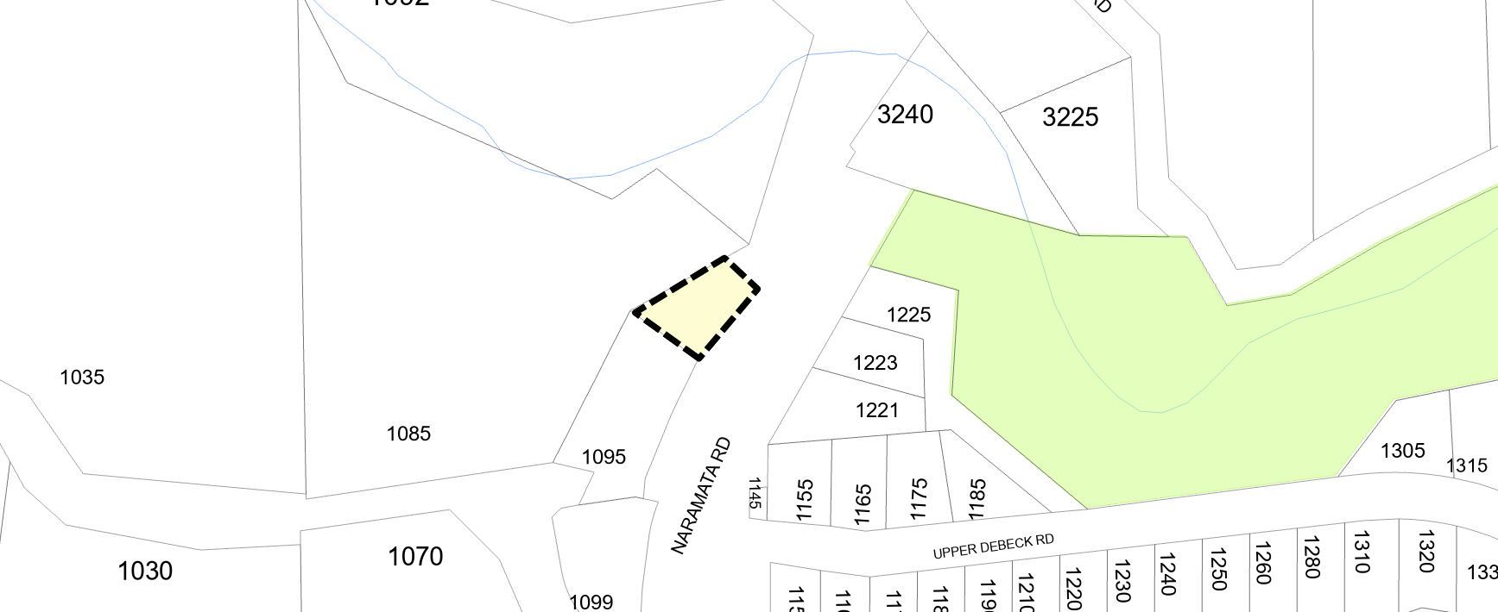

Subject Area

**Amend Zoning Bylaw No. 2800, 2022**:

from: Agriculture One (AG1)

to: Administrative and Institutional Site Specific (AIs)

(YELLOW SHADED AREA)