_________________

**BYLAW NO. 3010.03**

_________________

REGIONAL DISTRICT OF OKANAGAN-SIMILKAMEEN

BYLAW NO. 3010.03, 2025

A Bylaw to amend the Electoral Area “E” Official Community Plan Bylaw No. 3010, 2023

The REGIONAL BOARD of the Regional District of Okanagan-Similkameen in open meeting assembled, ENACTS as follows:

1. This Bylaw may be cited for all purposes as the “Electoral Area “E” Official Community Plan Amendment Bylaw No. 3010.03, 2025.”
2. The Official Community Plan Bylaw Map, being Schedule ‘B’ of the Electoral Area “E” Official Community Plan Bylaw No. 3010, 2023, is amended by changing land use designation on an approximately 650 m2 area of land, and shown shaded yellow on Schedule ‘A’, which forms part of this Bylaw, from Agriculture (AG) to Administrative, Cultural and Institutional (AI).

READ A FIRST AND SECOND TIME this _____ day of ___________, 2025.

PUBLIC HEARING held on this _____ day of ___________, 2025.

READ A THIRD TIME AND ADOPTED this _____ day of ___________, 2025.

_______________________ ______________________

Board Chair Corporate Officer

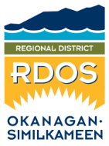Regional District of Okanagan-Similkameen

101 Martin St, Penticton, BC, V2A-5J9

Tel: 250-492-0237 Email: [info@rdos.bc.ca](mailto:info@rdos.bc.ca)

Amendment Bylaw No. 3010.03, 2025 File No. E2025.002-ZONE

Schedule ‘A’

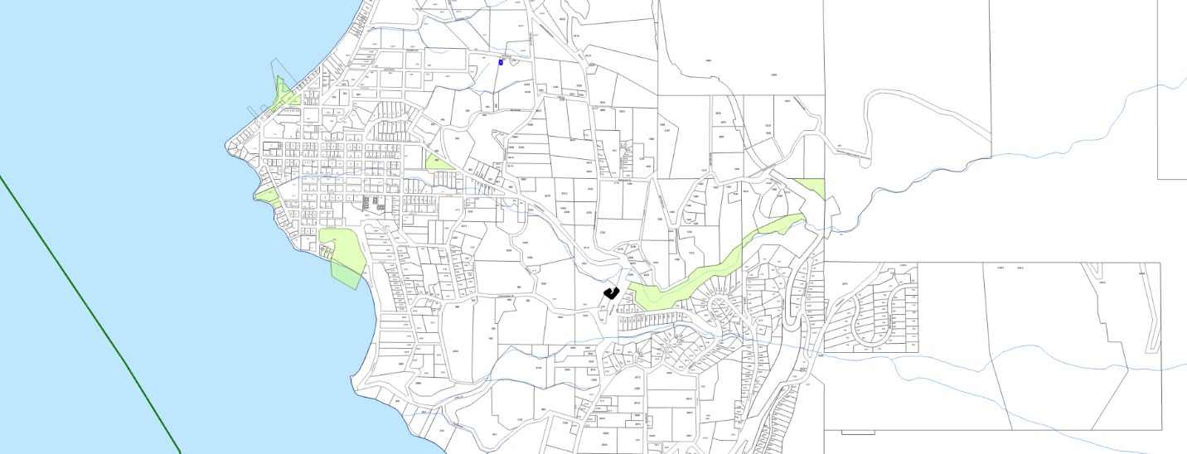



NARAMATA

Subject Area

Amend OCP Bylaw No. 3010, 2023

from: Agriculture (AG)

to: Administrative, Cultural and Institutional (AI)

(YELLOW SHADED AREA)

