**_________________**

# BYLAW NO. 2800.21

**_________________**

**REGIONAL DISTRICT OF OKANAGAN-SIMILKAMEEN**

**BYLAW NO. 2800.21, 2022**

**A Bylaw to amend the Okanagan Valley Zoning Bylaw No. 2800, 2022**

The REGIONAL BOARD of the Regional District of Okanagan-Similkameen in open meeting assembled, ENACTS as follows:

1. This Bylaw may be cited for all purposes as the Okanagan Valley Zoning Amendment Bylaw No. 2800.21, 2022.”
2. The “Okanagan Valley Zoning Bylaw No. 2800, 2022” is amended by:
3. adding a new sub-section 13.1.8(b)(iii) under Section 13.1.8(b) (Agriculture One Site Specific (AG1s) Regulations) to read as follows:
   1. In the case of land described as Lot 1, District Lot 2450S, SDYD, Plan 12996, and shown shaded yellow on Figure 13.1.8(b)(iii):
4. despite Section 7.2.7, an *accessory dwelling* in the form of a *mobile home* is permitted as an accessory use.

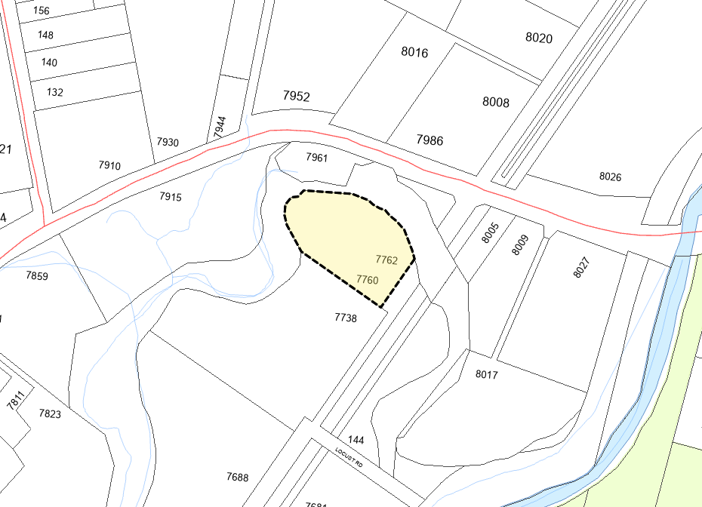

**Figure 13.1.8(b)(iii)**

**ISLAND ROAD**

**HIGHWAY 97**

Agriculture One Site Specific (AG1s)

(YELLOW SHADED AREA)

1. The Official Zoning Map, being Schedule ‘2’ of the Okanagan Valley Zoning Bylaw No. 2800, 2022, is amended by changing the land use designation on the land describe as Lot 1, District Lot 2450S, SDYD, Plan 12996, and shown shaded yellow on Schedule ‘A’, which forms part of this Bylaw, from Agriculture One (AG1) to Agriculture One Site Specific (AG1s).

READ A FIRST AND SECOND TIME this _____ day of ___________, 2022.

PUBLIC HEARING held on this _____ day of ___________, 2022.

READ A THIRD TIME this _____ day of ___________, 2022.

I hereby certify the foregoing to be a true and correct copy of the "Okanagan Valley Zoning Amendment Bylaw No. 2800.21, 2022” as read a Third time by the Regional Board on this ____ day of __________, 2022.

Dated at Penticton, BC this ____ day of __________, 2022.

____________________________

Corporate Officer

Approved pursuant to Section 52(3) of the *Transportation Act* this ____ day of __________, 2022.

______________________________________

For the Minister of Transportation & Infrastructure

ADOPTED this _____ day of ___________, 2022.

_______________________ _________________________

Board Chair Corporate Officer

****Regional District of Okanagan-Similkameen

101 Martin St, Penticton, BC, V2A-5J9

Tel: 250-492-0237 Email: [info@rdos.bc.ca](mailto:info@rdos.bc.ca)

Amendment Bylaw No. 2800.21, 2022 File No. C2022.016-ZONE

Schedule ‘A’

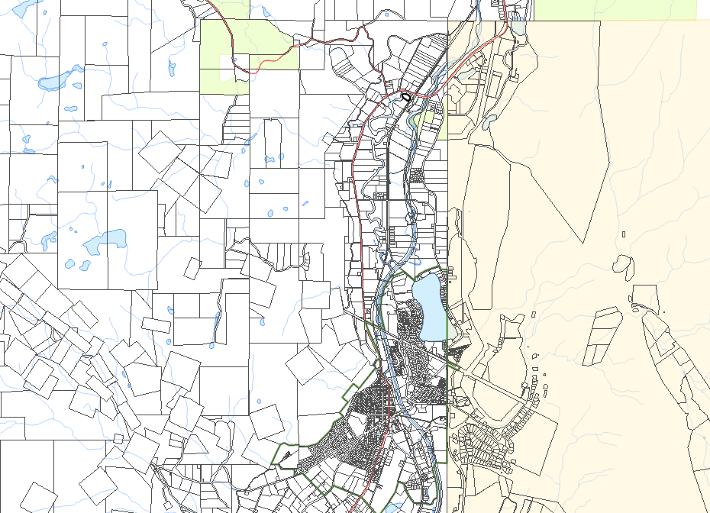





**OLIVER**

**Amend Zoning Bylaw No. 2800, 2022:**

from: Agriculture One (AG1)

to: Agriculture One Site Specific (AG1s)

(YELLOW SHADED AREA)

Subject Parcel